**IDX G9 PHYSICS S+ STUDY GUIDE**

**By Serena**

**2.8 Graphical Analysis of Linear Motion**

1. Position-time graph

A. No motion (at rest)

- Horizontal straight line/straight line parallel to the x-axis.

B. Uniform motion

- Slanted straight line

- y-intercept: initial position

- Intersection of graph lines two objects meet

- Average velocity

* The slope indicates the average velocity (m=rise/run=displacement/time interval)
* Steeper speed larger, |v| larger
* Instantaneous velocity
  + Constant v: instantaneous velocity=average velocity
* 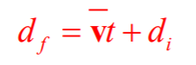Equation of motion for average velocity

C. Accelerated Motion

- Graph lines are many straight lines

- Graph line is a curve

* + Average velocity: the slope of connection of the two dots on the line
  + Instantaneous velocity: the slope of the tangent to the curve
  + Curve shape, v and +/- acceleration

D. Distance-time graph

- d-t graph does not have negative distance.

2. Velocity-time graph

A. Uniform motion (a=0)

- Horizontal line in v-t: v=constant, a=0

- y-axis: v of an object at any moment

- The area under the v-t graph is equal to the object’s displacement

* Above t-axis: displacement>0, below t-axis: displacement<0
* Meet: same area
* Average a: slope=0
* Instantaneous a: 0

B. Uniformly accelerated motion

- Slant straight line

- Slope=average a

- Instantaneous a=average a: a=constant

- In v-t graph: rising(a>0), descending(a<0)

- Steeper: |a| larger

C. Motion with changing a

- Instantaneous a = the slope of the tangent to the curve for a particular moment

D. Speed-time graph

- No negative speed

3. Acceleration-time graph

A. At rest/uniform motion a=0

- Horizontal line along t-axis

B. Uniformly accelerated motion

- Horizontal line parallel to t-axis

**3.1 Vectors and Scalars**

- Vectors have magnitude and direction

- Scalar only has magnitude, no direction

A. Representing Vectors

1. A line and an arrow

- Length: magnitude

- Direction: the direction

- Symbol: A ⃑ (boldface type + tiny arrow on top)

* If only magnitude is concerned: *A* (italics)

2. Direction of a vector

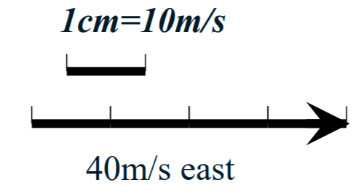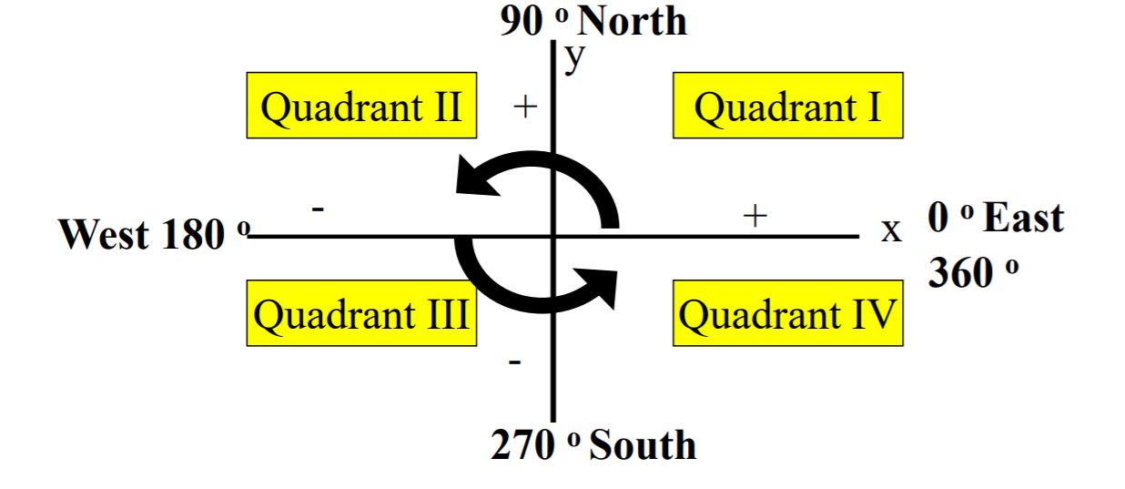3. Draw to scale

- At least two segments should be used to represent a single vector

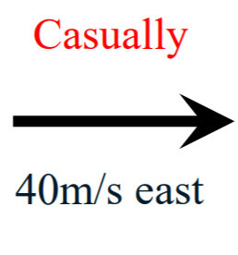4. Draw in casual way

**3.2 Addition of Vectors----Graphical Methods**

A. Tip-to-Tail Method

- The resultant/net is the sum of two or more vectors

- Commutative: A ⃑ +B ⃑ =B ⃑ +A ⃑

- To find the resultant:

1. Move the tail of one vector to the head of another vector without changing the magnitude or direction of the vector

2. The resultant points from the tail of the first vector to the head of the second (last)vector.

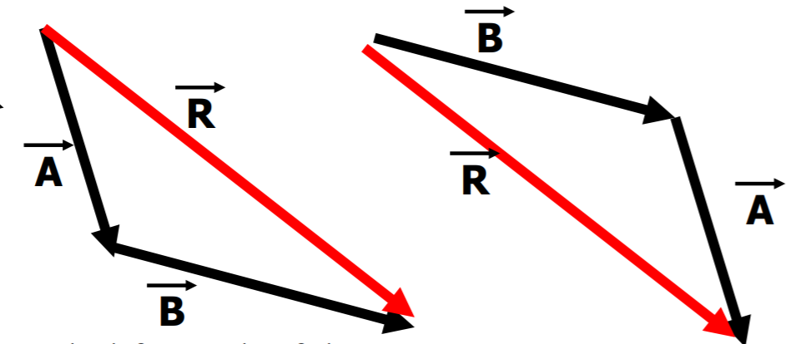- Vectors are in one straight line

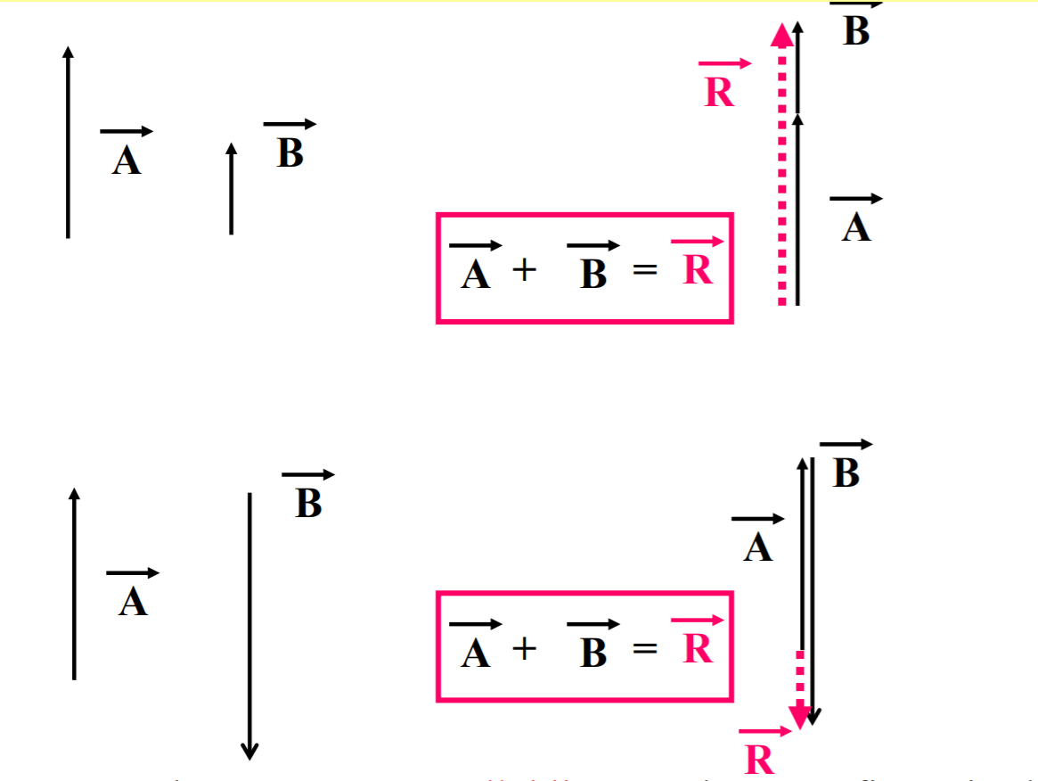- The magnitude of the vector sum is not always greater than the magnitude of either contributing vector.

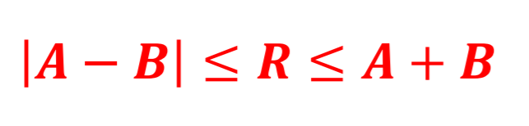- The magnitude of resultant of two vectors is never greater than the sum of magnitude of two individual vectors.

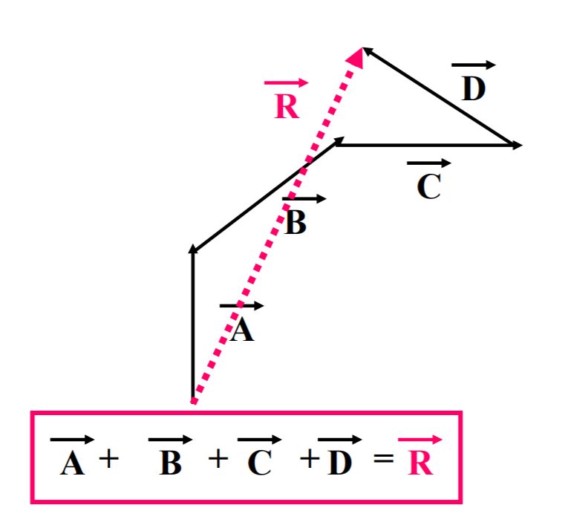- Resultant of more than one vector

- If three or more vectors form a closed polygon, there is no resultant.

B. Parallelogram Method

- Place component vectors tail-to-tail

- Use the two vectors as adjacent sides and construct a parallelogram

- The diagonal from the common origin is the resultant vector

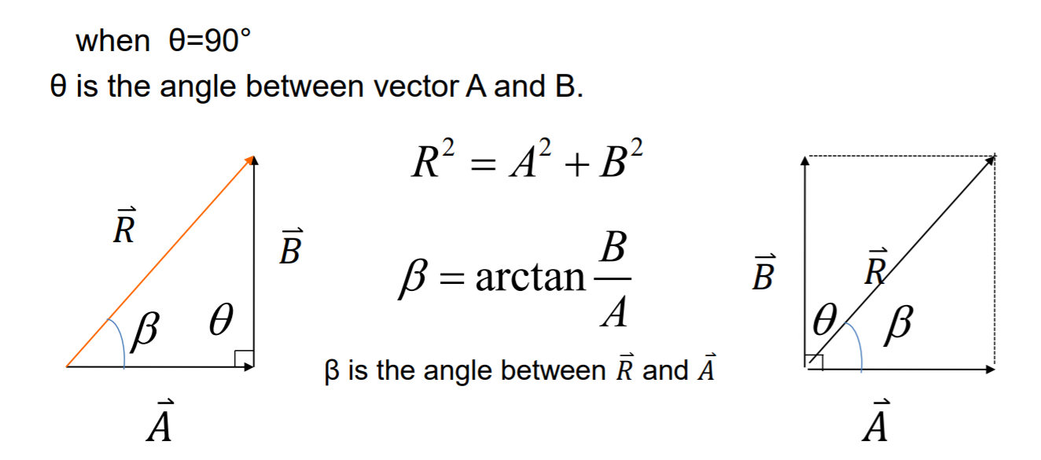C. Pythagorean Theorem

**3.3 Subtraction of Vectors, and Multiplication of a Vector by a Scalar**

A. Subtracting Vectors

1. Negative Vectors

- Two vectors are negative if they have the same magnitude but are 180˚ apart (opposite directions)

* A = -B
* A – B = A= (-B)
* If we add a negative vector B to vector A, this is subtracting vector B from vector A

B. Multiply the vector

- A vector 𝐴 ⃑ can be multiplied by a scalar c

- If c is positive number, then the product c𝐴 ⃑ has the same direction and has magnitude cA

- If c is negative number, then the magnitude still is cA and the direction is opposite to 𝐴 ⃑

**3.4 Adding Vectors by Components**

A. Vector components

- Once you place a vector in a coordinate plane, it can be broken down into compnents

* 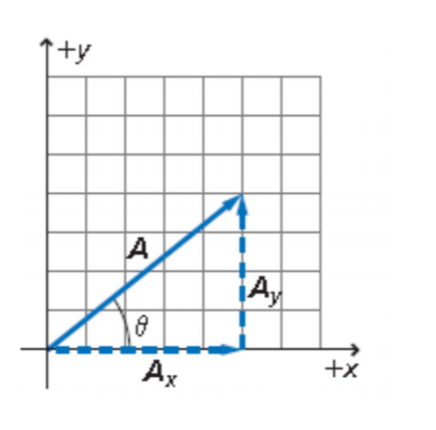This process is called vector resolution
* 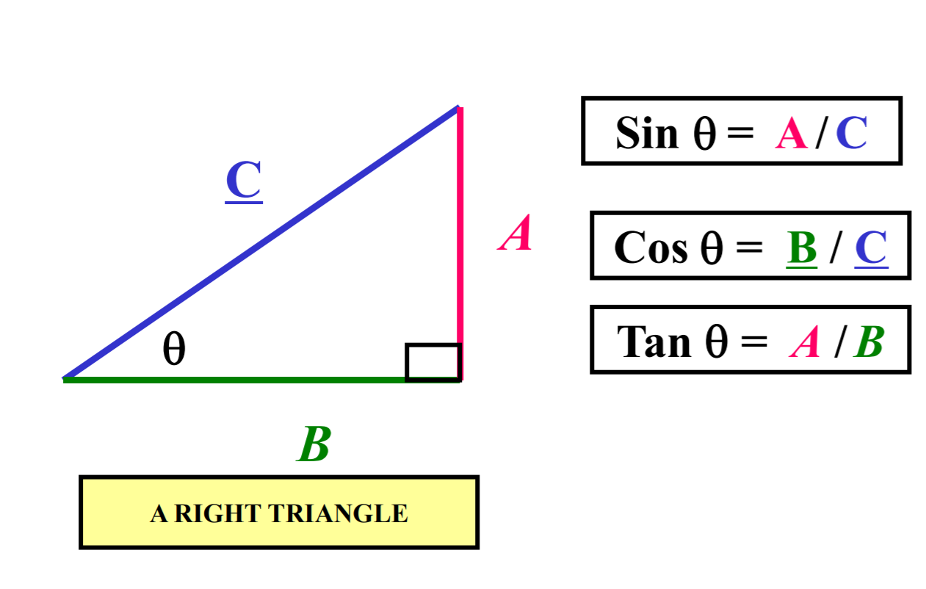The trigonometric functions
* 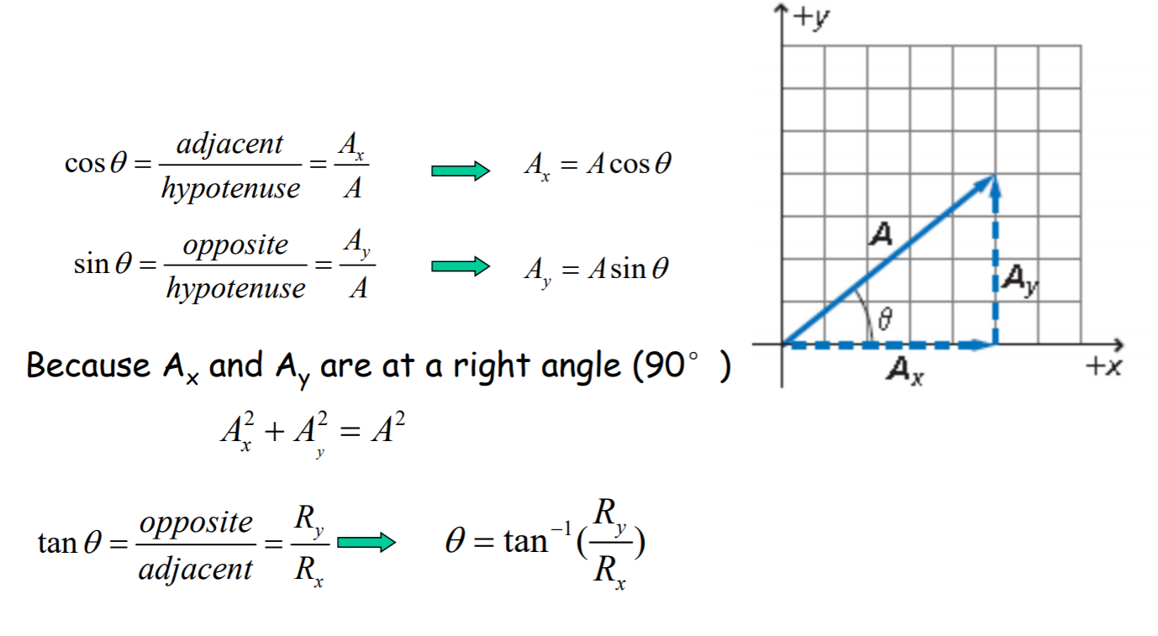 X and y components of a vector

B. Adding vectors using components

1. Resolve each vector into its x- and y- components

2. Adding the x-components of all the vectors

* 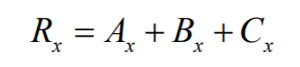X-components of the resultant
* 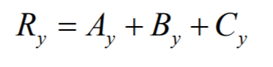Similarly

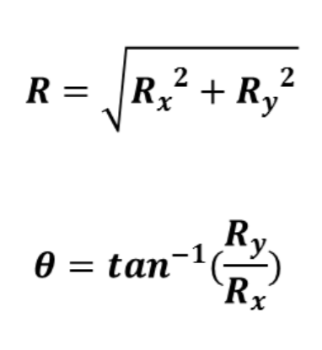3. Get the resultant

**3.5 Projectile Motion**

A. Concepts of Projectile Motion

- Projectile: An object shot through the air

- Trajectory: The curved flight path that is followed by a moving object

- After a projectile is launched, gravity=net force

- Projectile motion is a combination of two independent motions

* Horizontal motion component: motion with constant velocity when there is no air resistance
* Vertical motion component: motion with constant acceleration

B. Projectile launched horizontally

- A projectile launched horizontally has no initial vertical velocity

- Horizontal and vertical motion are analyzed separately

* Horizontal motion (range): constant v
* Vertical motion (height): free fall
* The velocity vector at each instant is always tangent to the parabola
* 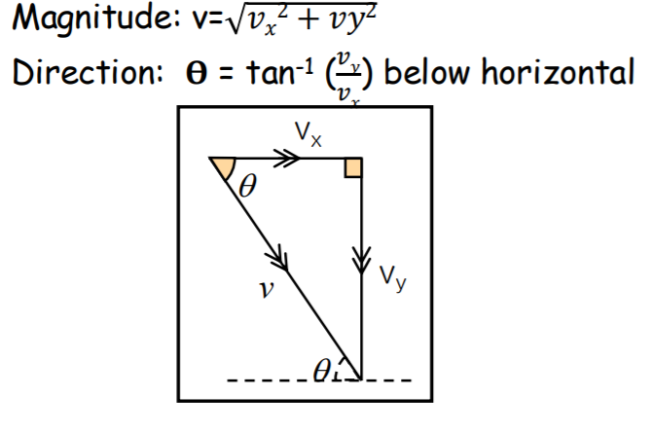Final velocity before hitting the ground
* The horizontal and vertical motions are independent
* The time from the launch to hit the target is the same for both horizontal and vertical motion
* An object projected horizontally will reach the ground in the same time as an object dropped vertically
* Factors affecting the range the projectile falls away
* The horizontal velocity
* 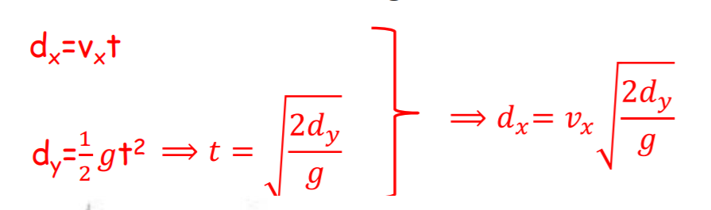The flight time (The height it falls)